
LORD KRISHNA RESIDENCY, RWA (Regd.)
Park Elite Floors, V-Block, Sector - 76, BPTP, Greater Faridabad
UPDATED COMMITTEE LIST
Transcription note: Blank handwritten fields remain blank. Please verify entries marked * against the original photograph.
Position | Name | Address / Unit | Mobile
President | Bhagwat Ram Uniyal | V-11/2, G. Floor* | 9999867226
Genl. Secretary | Shantos Sharma* | V-11/08, Ground Floor, Park Elite Floors, Sec-76, BPTP | 9311350641
Vice President | Surjeet Singh |  | 9811728982
Treasurer | Shekhar Sharma | V-11/6, 1st Floor | 9999806330
Joint Secretary | Varun Tomer* |  | 8130889150
Member | Ashok Kumar
Member | Dheeraj Kumar |  | 8527191129
Member | Shiv Ram |  | 8527191129
Executive Member 1 | Mahendra Pal*
Executive Member 2 | Pradeep Kapoor*
The original photograph is included on the following page for reference.

SOURCE PHOTOGRAPH
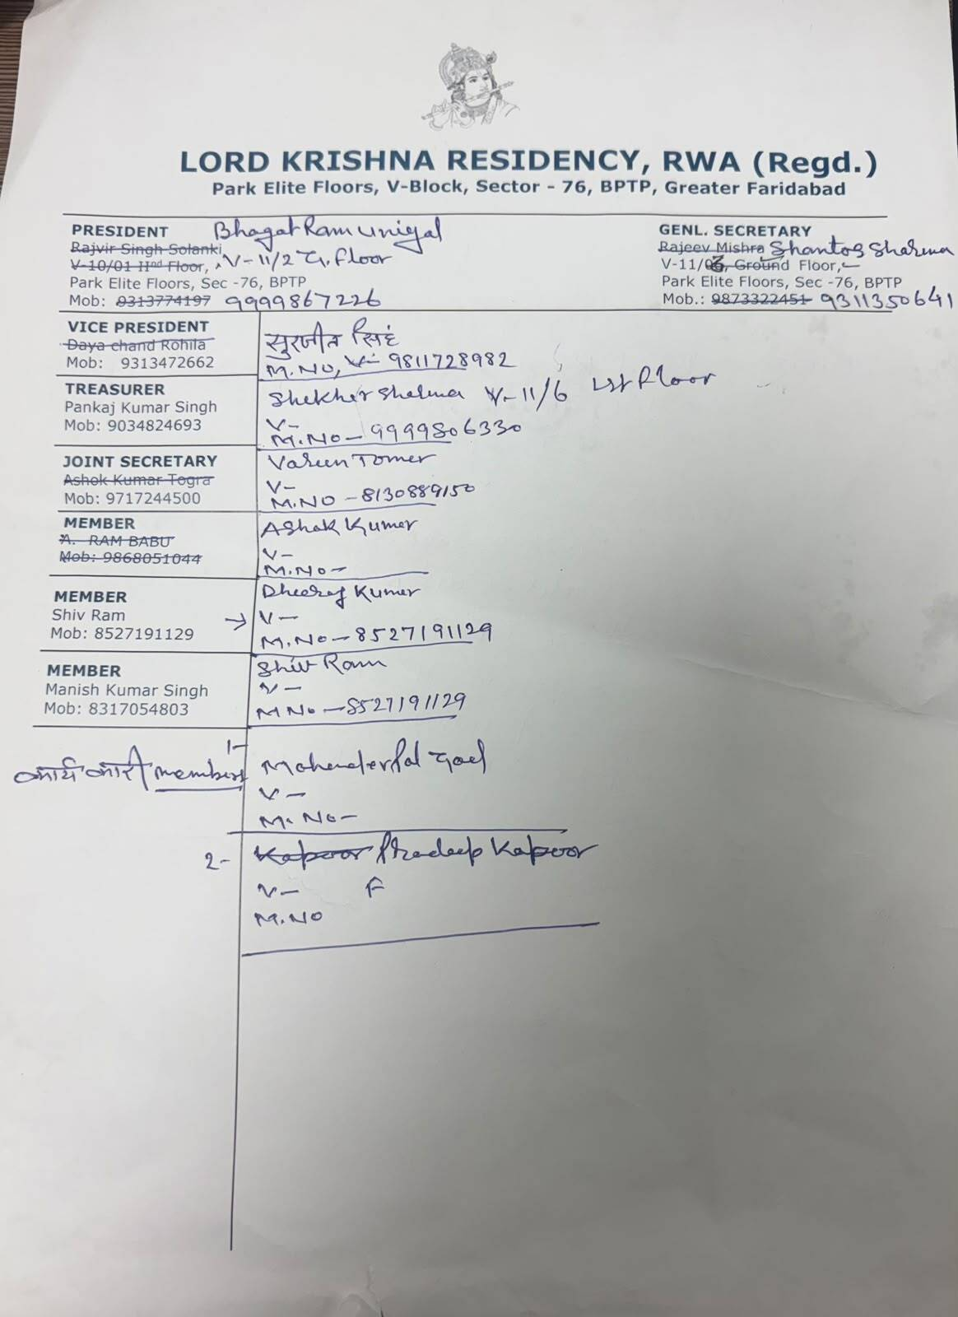
Original image supplied for transcription and verification.

